Two Lights for Tomorrow Educational Toolkit: Illuminating Paul Revere’s Ride
  - January 12, 2025 – V.2

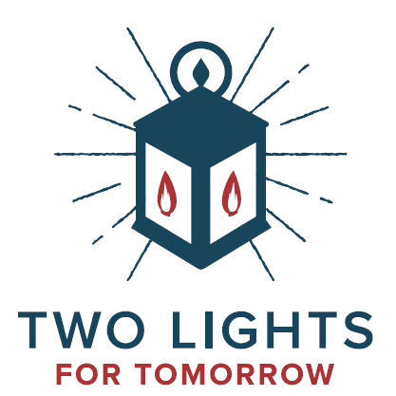
Introduction:
Two Lights for Tomorrow is a nationwide initiative to commence the celebration of the 250th birthday of the United States of America. The famous ride of Paul Revere occurred overnight on April 18 – 19, 1775. Two Lights for Tomorrow commemorates that famous ride and uses the imagery of that shining light today as a uniting call to action for our citizens to celebrate and serve.
We invite educators, parents, and students to complete the following activities to participate in this nationwide campaign.

Activities:

Paul Revere's Ride Interactive Timeline
- Create a large timeline on the classroom wall or at home, marking key 1775 events leading up to April 18th. Students can add illustrations and facts about Paul Revere's ride.

Two Lights Diorama
- Students create dioramas depicting the "Two Lights" signal from the Old North Church. Use shoe boxes, LED lights, and craft materials.

Midnight Ride Comic Strip
- Students design a 6-panel comic strip illustrating Paul Revere's famous ride, emphasizing the importance of communication during the American Revolution.

Lantern Craft
- Materials: Mason jars, battery-operated tea lights, construction paper
- Instructions: Cut colonial-lantern-inspired designs from construction paper and glue them to the outside of the jar. Place the electric candle inside to create a "signal lantern."

Paul Revere's Ride Scavenger Hunt
- Create a list of items related to the midnight ride (e.g., horse, lantern, church) for students to find around their home or neighborhood.

Family History "Ride"
- Students ask parents to share a story about their heritage using the America250 in Idaho “Echoes of Idaho” story-capturing portal to reflect on their own "journey" through history.
- https://theirstory.io/IdahoStateHistoricalSociety/TheEchoesofIdaho:TellUsYourGemStateStory/s/t-w4ffGz2b/solo

Connecting to Two Lights for Tomorrow:

Writing Assignment
- Have students write short essays on how they can be "lights" in their community through service projects and consider donating those essays to your local historical society.

Service Learning
- Organize a class service project for April 18-19, 2025, inspired by the Two Lights for Tomorrow campaign.

Promote Awareness:
- Create a "Two Lights for Idaho" display in the classroom, displaying student ideas for community service.

Interdisciplinary Learning
- Read Henry Wadsworth Longfellow's poem "Paul Revere's Ride" aloud in class. Compare Longfellow's poem to Paul Revere's own account of the ride. Discuss the differences between primary and secondary sources.
  - Paul Revere’s recollections: https://www.masshist.org/database/viewer.php?item_id=99
  - Longfellow’s poem: https://www.paulreverehouse.org/longfellows-poem/
- Ask students to write poems about a modern-day hero in their community.

Interactive Learning
- Watch the America Battlefield Trust’s educational video content documenting Revere’s route.
  - Video link: https://www.battlefields.org/learn/videos/paul-reveres-ride

Significance & Alignment with State Curriculum
By engaging in these activities, Idaho students can learn about Paul Revere's historic ride and connect it to the broader themes of civic engagement and community service emphasized by the Two Lights for Tomorrow campaign. This approach combines historical learning with contemporary relevance, encouraging students to participate actively in their communities.
- Inquiry-based learning emphasizes student-driven inquiry projects, which aligns with Idaho's focus on developing critical thinking and research skills.
- Video content supports active learning, consistent with Idaho's approach to engaging students in social studies content.
- Interactive and technology-based learning emphasizes the use of various tools, such as maps, globes, graphs, and geospatial products.
- Primary source analysis is a key skill in Idaho's social studies standards, particularly in history.

The link for the “Echoes of Idaho” story-capturing portal requires acceptance of terms and conditions.

